Initial UI Design

Need to photocopy paper version.

scope

# Initial Prototype

Start Screen Image = https://wallpapershome.com/space/stars-star-trail-galaxy-sky-4k-6k-18295.html

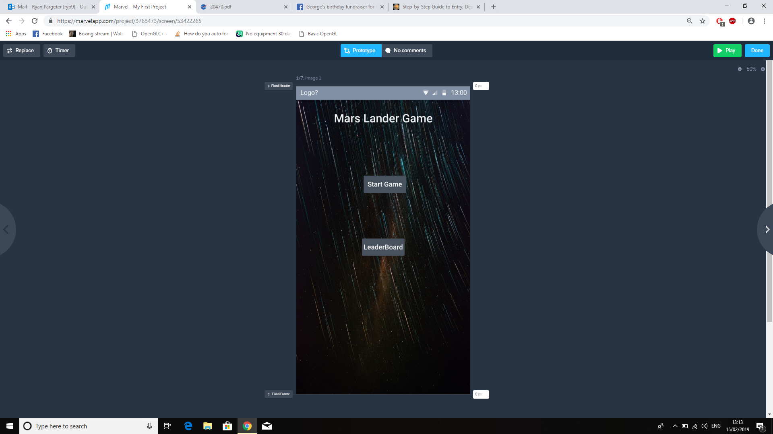

My Main screen will be a very simple two button design with a start game and a leader board.

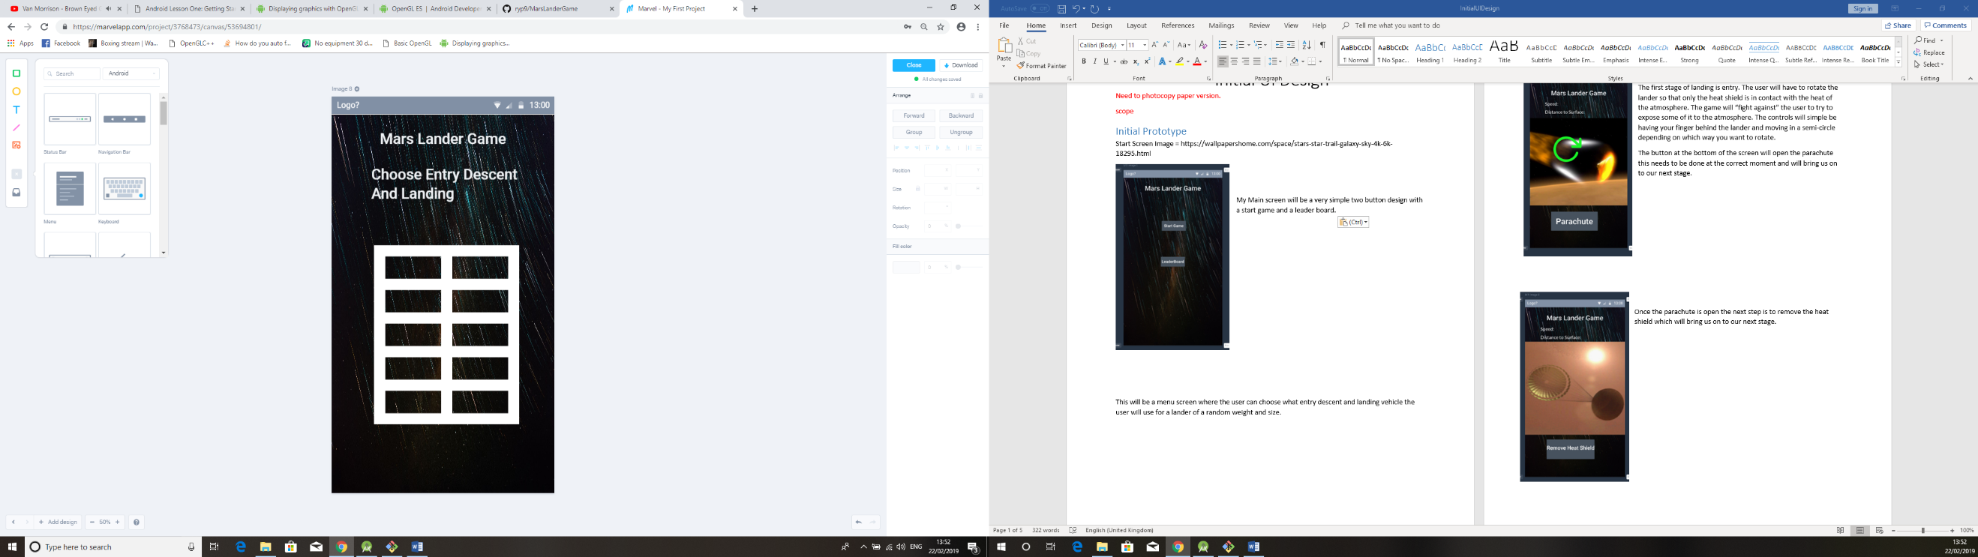

This will be a menu screen where the user can choose what entry descent and landing vehicle the user will use for a lander of a random weight and size.

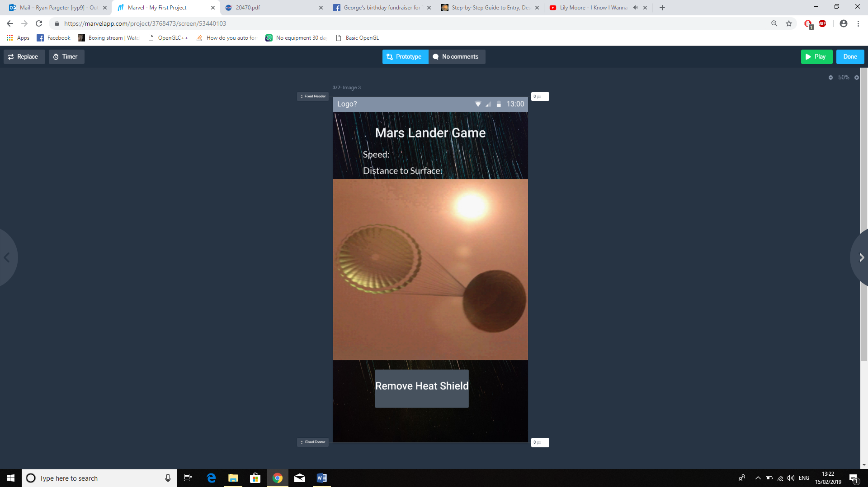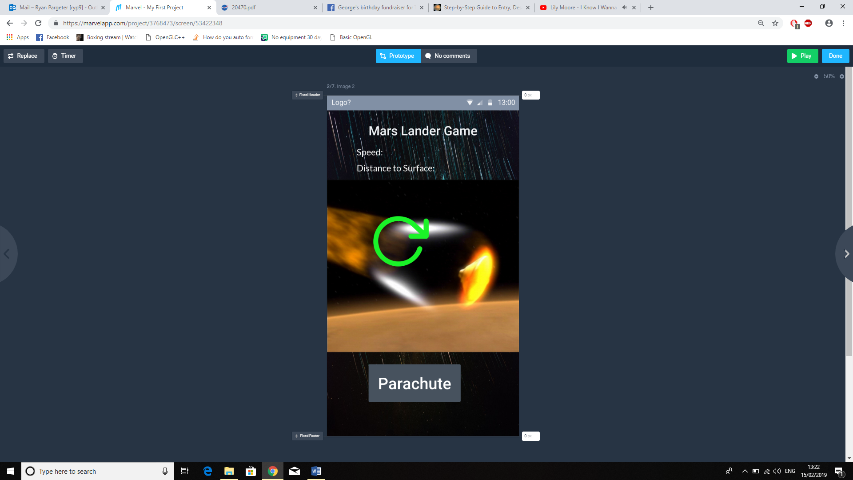

The first stage of landing is entry. The user will have to rotate the lander so that only the heat shield is in contact with the heat of the atmosphere. The game will “fight against” the user to try to expose some of it to the atmosphere. The controls will simple be having your finger behind the lander and moving in a semi-circle depending on which way you want to rotate.

The button at the bottom of the screen will open the parachute this needs to be done at the correct moment and will bring us on to our next stage.

Once the parachute is open the next step is to remove the heat shield which will bring us on to our next stage.

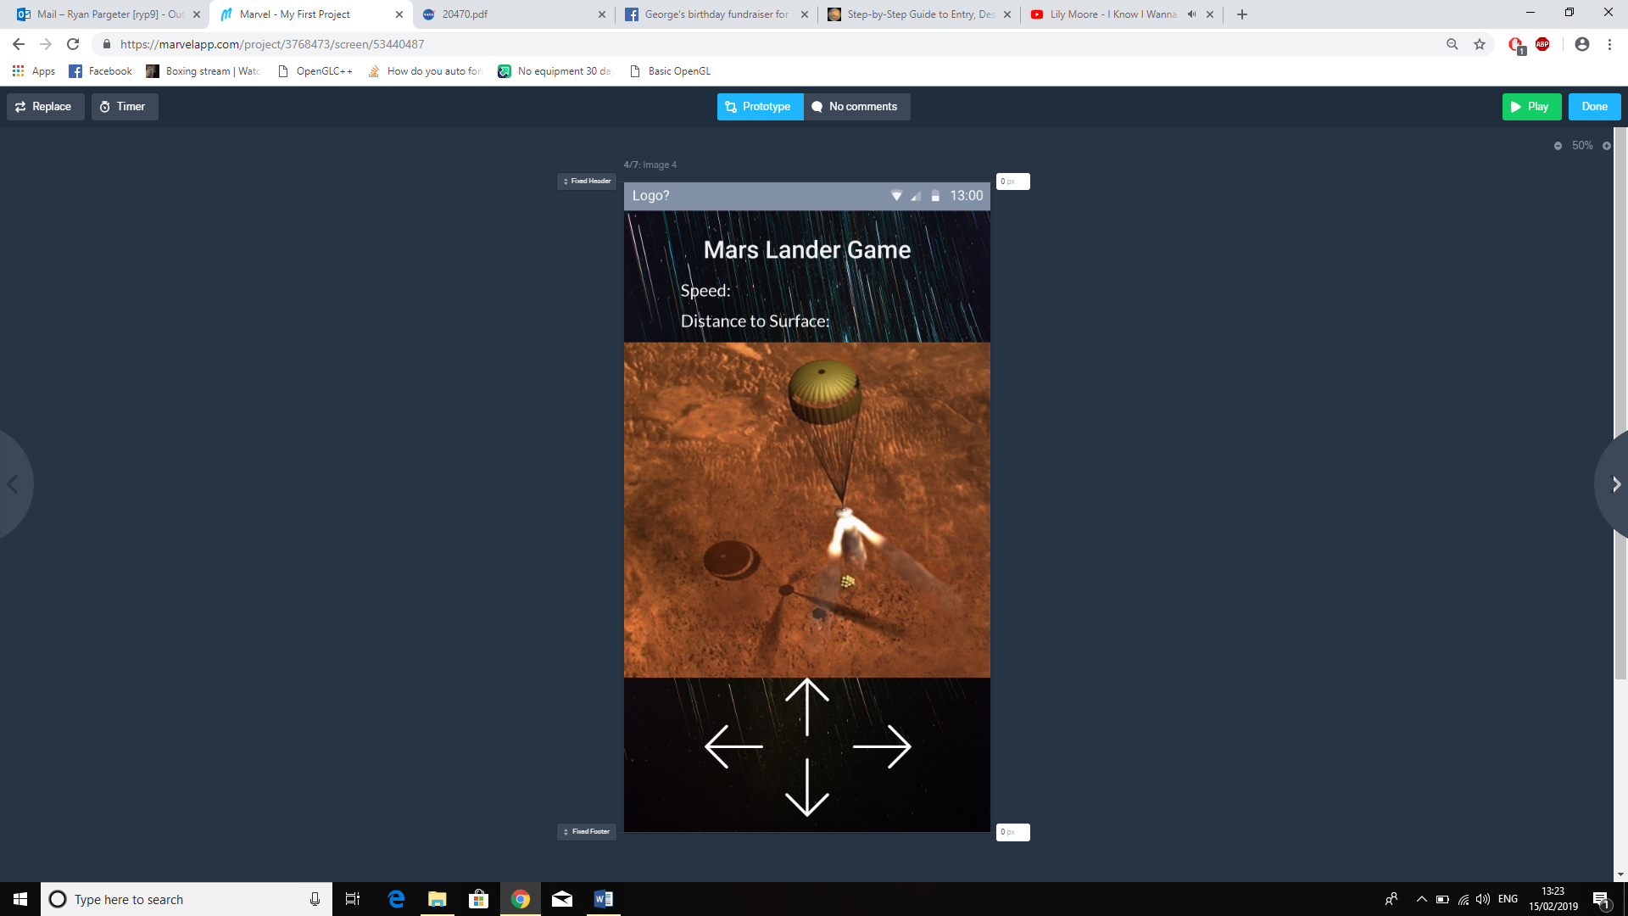

These arrows will provide thrust, we will have a limited amount of fuel and so it needs to be used conservatively. This phase will be used to both slow the lander and move the lander horizontally so the user can pick a preferred landing site.

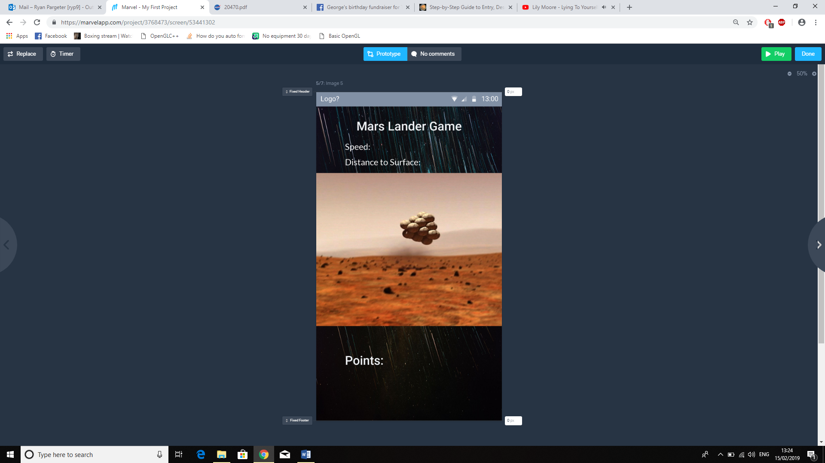

This phase the parachute will come off and the bouncing gas bags will either pop if we are coming in too fast or bounce in a realistic way. When it finally settles the user’s points will be calculated.

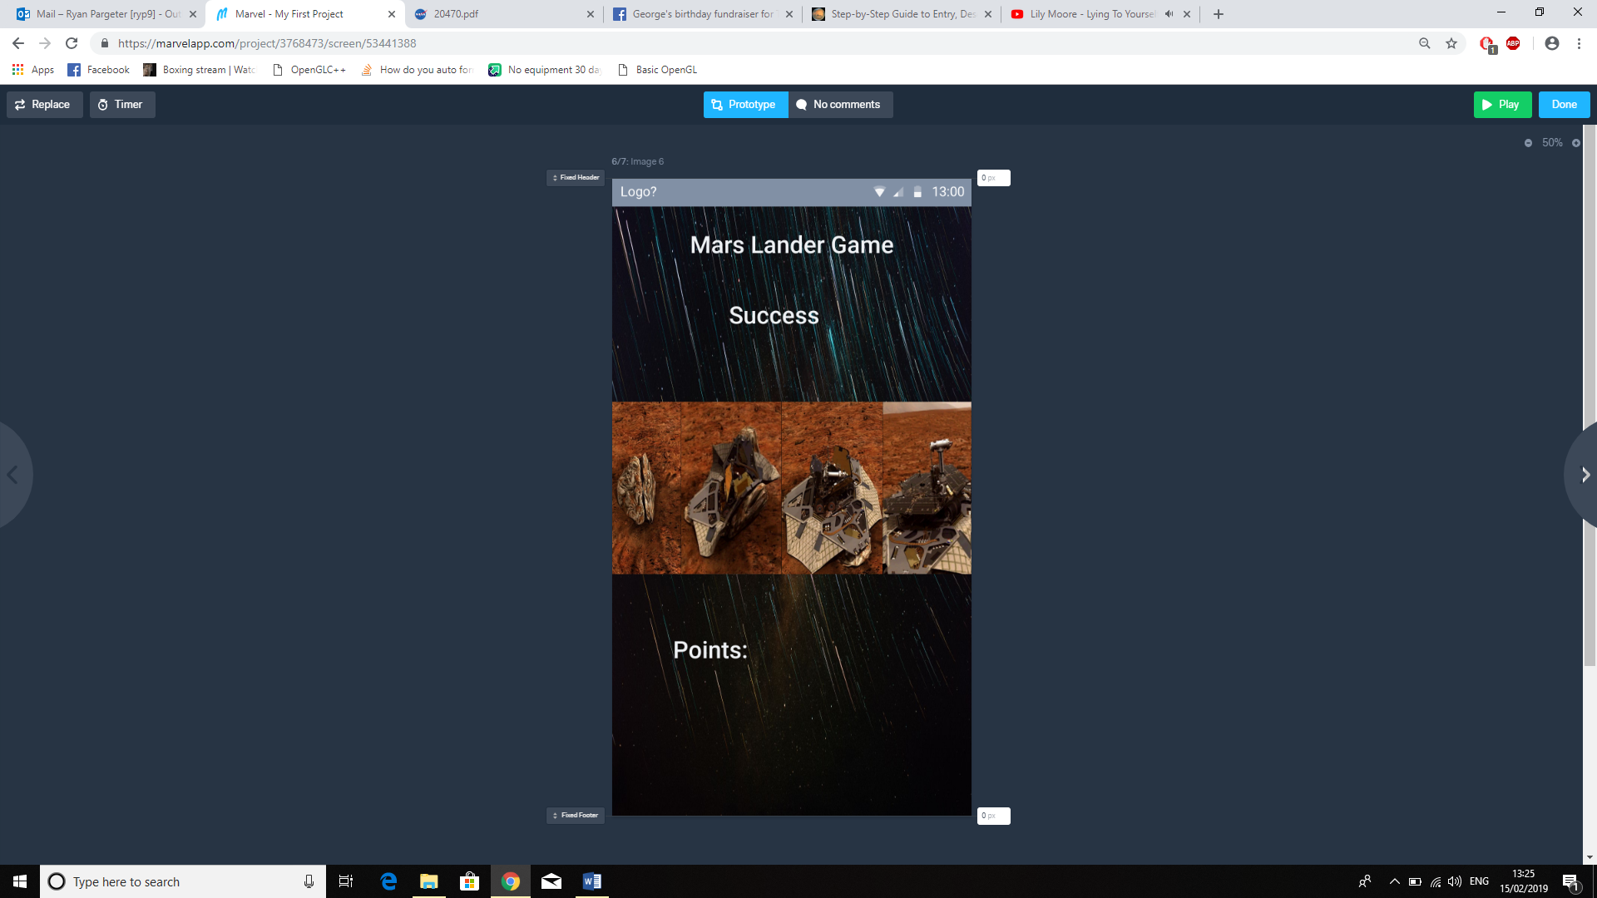

This is the final screen of the lander opening. The points will be adding up and displayed to the user.

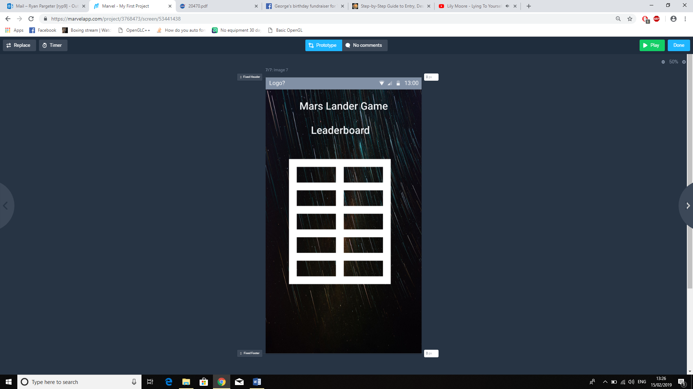

This is the final screen of the user points being added on or the screen that appears when the user clicks on the “Leader Board” button on the main screen.